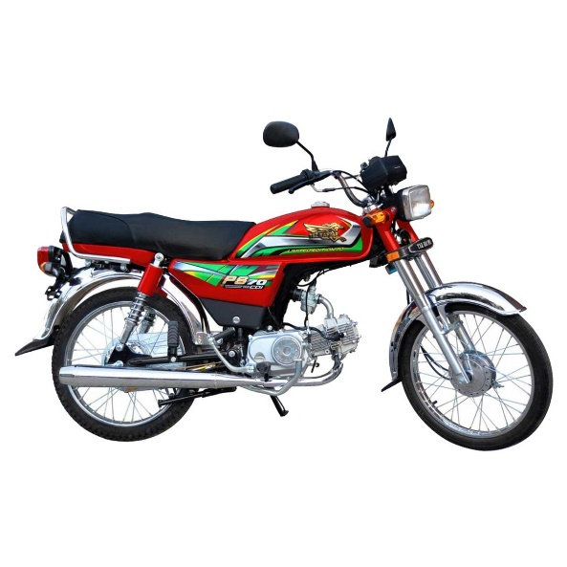

Tez Raftar 70cc Motorcycle - PS70 Motorbike (Lahore, Gujranwala, Sialkot, Islamabad, Karachi & Faisalabad only)

Product details of Tez Raftar 70cc Motorcycle - PS70 Motorbike (Lahore, Gujranwala, Sialkot, Islamabad, Karachi & Faisalabad only)

* Tez Raftar 70cc Motorcycle - PS70 Motorbike (Lahore, Gujranwala, Sialkot, Islamabad, Karachi & Faisalabad only)

TEZ Raftar 70cc Motorcycle - PS70 Red Motorbike (Lahore , Gujranwala , Sialkot , Islamabad , Karachi & Faisalabad Only)

|  |  |
| --- | --- |
| Engine Type: | Wet sump, Single Cylinder, Four Stroke, Two Valves, Air Cooled with SOHC (Single Over Head Cam) Chain Drive |
| Bore & Stroke | 47.0 x 49.5 MM |
| Piston Displacement | 70cc |
| Compression Ratio | 8.8:1 |
| Starting | Kick Starter |
| Ignition | Capacitor Discharge Ignition (CDI) |
| BHP (Max) | 4.2 kW @ 8,500 rpm |
| Torque (Max) | 5.8 N-m @ 7,500 rpm |
| Transmission Type | Four Speed Constant Mesh (Multi disc wet type clutch) |
| Chassis Type | Back Bone Type Iron Pipe Swing Arm |
| Length*Width* Height | 1897*751*1014 (mm) |
| Wheel Base | 1200mm |
| Tyre Front | 2.25 17 4 PR |
| Tyre Rear | 2.50 17 4 PR |
| Ground Clearance | 135mm |
| Dry Weight | 82 kg |
| Fuel Tank (Capacity) | 9 Liters/1 Liter Reserve |
| Battery | 12V 3.5A |
| Warranty | 6-Month OR 6000 km(Whichever comes first)  Along with 2-Free Service Coupons |

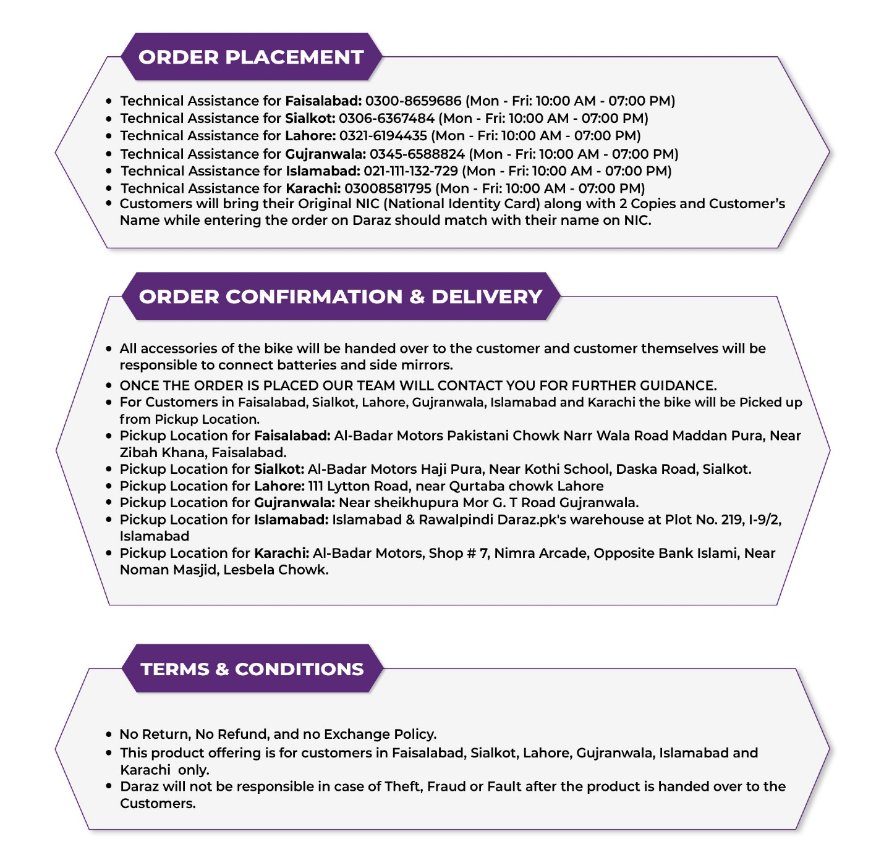

Specifications of Tez Raftar 70cc Motorcycle - PS70 Motorbike (Lahore, Gujranwala, Sialkot, Islamabad, Karachi & Faisalabad only)

* Brand

Tez Raftar

* SKU

265679349_PK-1481713835

* Engine displacement (cc)

70 CC

* Location

Lahore,Islamabad,Karachi,Gujranwala,Sialkot,Faisalabad

* Number of Cylinders

1

* Number of Gears

4

* Model Year

Model Year- 2022